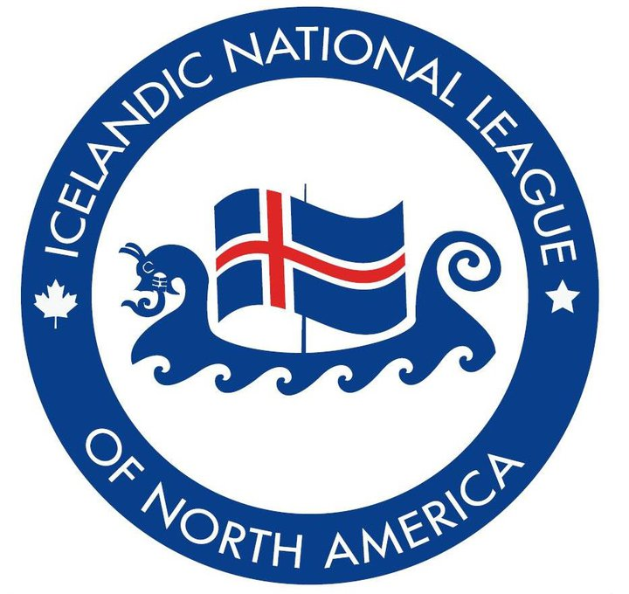

**Icelandic National League of North America**

**(Þjóðræknisfélag Íslendinga í Vesturheimi)**

**103 – 94 1st Ave, Gimli, MB ROC 1B0**

[**www.INLofNA.org**](http://www.INLofNA.org)[**INL@mymts.net**](mailto:INL@mymts.net)

**INLNA Second Century Statement**



**History:**

Founded in 1919, in Winnipeg, by visionary Icelandic immigrants to Canada and the United States, the not-for-profit Icelandic National League of North America (INLNA) serves member-clubs, individual members, Icelandic immigrants, Icelanders, and friends of Iceland. Member-clubs manage their own local activities, with some assistance from the INLNA. Further archival historical detail is in its: **2019 Centennial Report**([**https://inlofna.org/s/100-Anniversary-booklet.pdf**](https://inlofna.org/s/100-Anniversary-booklet.pdf) ).Current INLNA programs are listed in detail on its website: [**www.INLofNA.org**](http://www.INLofNA.org).

**Mission:**

The INLNA sustains the kinship between: its Canadian, American, and Icelandic members; North Americans interested in Iceland and matters Icelandic; and Icelanders implicit in its motto, **Strong is the Bond/Römm er sú taug**, through activities which celebrate, share, and preserve the breadth of Icelandic culture, language, literature, customs, and heritage.

**Vision:**

Regardless of Icelandic-descent, all who are interested in Iceland and matters Icelandic are welcome to join INLNA’s second century of serving its members and communities. INLNA’s goal is to: celebrate, share, preserve, and honour its Icelandic legacy in its Second Century.

**Membership:**

For INLNA membership information or to contact a nearby member-club: [**INL@mymts.net**](mailto:INL@mymts.net).

***[Approved by the INLNA-2021 Virtual AGM, 15-May-2021.]***

**BACKGROUND:**

After considerable discussion and revisions, the INLNA Board approved the foregoing “Refreshed” Statement at its 8-March-2021 Board Meeting and will recommend its approval by the General Membership at the 2021 INLNA virtual Annual General Meeting, 15-May-2021.

This updated statement neither abrogates nor replaces the original purpose statements embedded in INLNA’s organizing, legal documents, e.g., its Letters of Incorporation:

• To encourage people of Icelandic descent to become the best possible citizens of their new homeland.

• To maintain and strengthen the Icelandic language and literature in North America.

• To work in cooperation with all Icelanders on both sides of the Atlantic.

The Statement reflects: realities, challenges, and opportunities in INLNA’s Second Century. A century has passed since visionary Icelandic immigrants founded the INLNA in 1919, a year after the carnage of World War I and the Spanish Flu pandemic. Their aspirations for their descendants to become productive citizens of Canada or the United States have long-since been realized. INLNA’s founders were fluent in Icelandic but that is no longer the case. Except for: the 2020 INLNA Calendar which featured the Icelandic language, INLNA Reads which features Icelandic literature in English-translation, and the Donald K. Johnson-sponsored Icelandic video series which features Icelandic-with-English-sub-titles (or vice-versa), the INLNA, itself, no longer actively teaches Icelandic. (Icelandic instruction is provided by many individual Member-Clubs.) What remains a constant is INLNA’s regard for the breadth of Icelandic culture, literature, customs, and heritage. What endures is INLNA’s honouring its Icelandic legacy, its birthright, which members have sustained since 1919. What continues is INLNA’s collaboration with relevant Nordic and Icelandic organizations in North America and Iceland. The Statement interprets the implications its Motto: **Strong is the Bond/Römm er sú taug**. The Statement provides information useful to potential new INLNA members and donors.

INLNA’s 2019 Centennial Report, a treasure-trove of historical information, is hyperlinked. INLNA’s website, [**www.INLofNA.org**](http://www.INLofNA.org), provides detailed contemporary information.

In 1919 INLNA’s constituency was exclusively Icelanders, Icelandic immigrants, and Western Icelanders of Icelandic descent. Continuing to honour INLNA’s Icelandic heritage and legacy well into the future will entail welcoming all who are interested in Iceland and matters Icelandic.