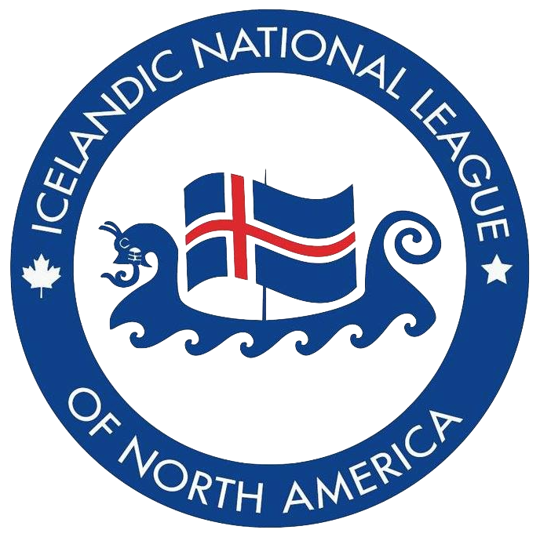

Icelandic National League of North America
Awards Nomination Form

Please complete all six steps below…

Step 1: Review the INLNA Awards Nomination Criteria

Step 2: Check the shaded box to select the award for which you wish to complete the nomination. If you make an error, simply click on the box again to deselect.

INLNA Honorary Lifetime Membership Award
Joan Inga Eyolfson Cadham Award
Laurence SG Johnson Lifetime Achievement Award
Convention Registration Award - SELF NOMINATION

Step 3: Please click on the shaded box and begin typing to complete all information for the nominee (individual you are nominating).

Full Name:
Phone number:
Mailing address:
Email address:
Name of INLNA Club(s) membership:

Step 4: Please click on the shaded box and begin typing to complete all information for the nominator (individual submitting the nomination).

Full Name:
Phone number:
Mailing address:
Email address:
Name of INLNA Club membership:

Step 5: On the next page please write a summary explaining how the nominee meets/exceeds the award criteria. Please click on the shaded box and begin typing.

Step 6: Now, save this 2-page document as a PDF and submit it to the INLNA via email inlofna@gmail.com before the January 31st.

Nominee’s name:
Please write a summary in the expandable shaded box explaining how the nominee meets/exceeds the award criteria.

